**Final Project Written Report**

Amanda J. King

Department of Forestry and Natural Resources, Purdue University

FNR 498: Ecological Sensors and Data

Dr. Jacob Hosen

May 8, 2021

**Introduction**

During the second half of the spring semester of 2021, the FNR 498 Ecological sensors and data class learned how to put together, code, and set up a couple of different sensors. After deploying our sensors, Dr. Hosen asked the class to come up with different ideas and proposed a research project for our last assignment. For this project Dr. Hosen also gave the class the option to look at past data sets, and he also allowed the class to work individually, in partners, or in small groups. For this assignment, I chose to collaborate with my fellow classmate and friend Kiera Mann. Despite some trials and unforeseen difficulties, Kiera and I were able to expand our comprehension of air quality and other climatic features of North Central Indiana compared to central Florida.

**Methods and Thought Processes**

When this project was first proposed to the class, Kiera and I thought that we would have the chance to deploy the air sensors we put together and set up to collect data. Unfortunately, due to technological malfunctions on the school’s end, we were unable to set up our sensors. Therefore, Kiera and I adapted and attempted to create a project from the data collected from the previous class in the spring of 2020. The first task we completed was to analyze the excel sheet with the data points and pinpoint the location of each sensor. Additionally, we made note of which sensors were outdoors or indoors. After some careful pondering, Kiera and I decided that we wanted to look at the data from outdoor sensors. We chose to compare outdoor sensors because we were uncomfortable comparing the indoor data due to a lack of contextual information. The only information readily available to us was the location of the building and the type of stove in the building. The building’s age, purpose, occupancy, and cleaning schedule was not included. The former factors have the potential to influence the data, and therefore should be considered when looking at the results. Although many factors can also influence outdoor air quality data, there are a variety of resources that provide the public with history of past weather events, climate patterns, and other air quality data. After looking at the locations of the outdoor sensors, we noticed that two of the sensors were in Florida. Because we both wanted to look at data from a different region, we originally intended to compare these two data sets. Despite the former, we yet again ran into a technological issue when it came time to assemble the data and plot it on graphs. Unfortunately, we had to change the data set we initially wished to compare to another set that was not experiencing issues. Therefore, Kiera and I decided to compare a data set that was collected from a sensor named Outdoor_AQ in Gainesville, FL and another data set collected from a sensor named Peru_IN_Outdoor_AQ in Howard County, IN. We chose to compare these data sets because the two of us were curious to see how the data would differ from one another. Thus, we inferred that the data would be different because of the difference in location, climate, and from our own personal experiences when visiting both regions.

**Results**

After compiling the data into graphs, Kiera and I were enabled to see how the data was either different or similar to one another. Below are the graphs, interpretation of the visual data, and further implications of this data. Additionally, it is important to note that the sensor in Indiana did not start collecting data until about three weeks after the Florida sensor started collecting data, so there is a decent gap of time where we could not compare the data sets.

**AQ Sensor Raw**

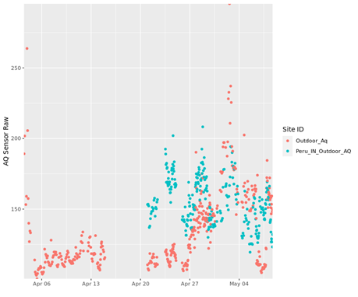

AQ Sensor Raw measures the concentration of volatile organic compounds (VOCs). According to the Minnesota Department of Health’s website, VOCs can come from a variety of sources such as paints, upholstery, air fresheners, cleaning products, cosmetics, gasoline, and burning wood (Volatile). From class we also learned that the aromatic molecule flowers release are VOCs and are therefore detected by the air quality sensors. When looking at this data Kiera and I noticed that Florida had many high outliers but overall had a lower VOC concentration than the Indiana location. This puzzled us because we thought that Indiana would have a lower VOC concentration since the location was in a more rural environment. Then we remembered that during the pandemic many people did not leave their homes, so that could explain why the VOC concentration was much lower.

**Temperature**

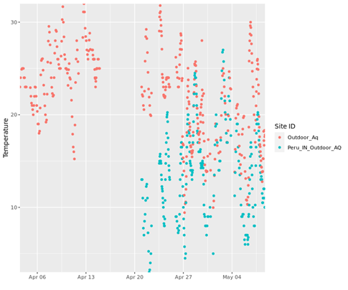

Based on the graph it is easy to see how the temperature differs between these two locations. The temperatures in Florida are obviously higher than the temperatures in Indiana, but we noticed an interesting trend between the two plots. It seems appears that when the temperature in one area increases, the temperature in the other area also increases and something similar happens when the decreases too. Kiera and I were astounded because we really had no idea that this was occurring.

**Dust Ratio**

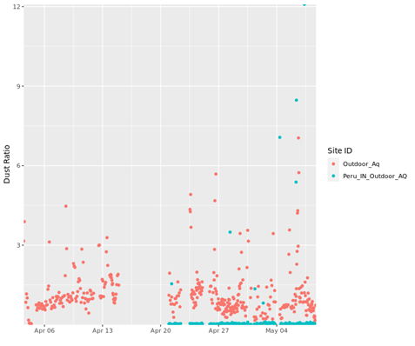

When looking at the graph above, one can observe the difference in dust ratios between the two locations. The location in Florida appears to experience a dustier climate on average than in Indiana. Despite the former Indiana location had a couple outliers that surpassed some of the Florida data points. These outliers appear to occur at even intervals, so one possible theory to attribute to the former could be when the lawn is mowed it disturbed the ground and flung dust particles into the air.

**Humidity**

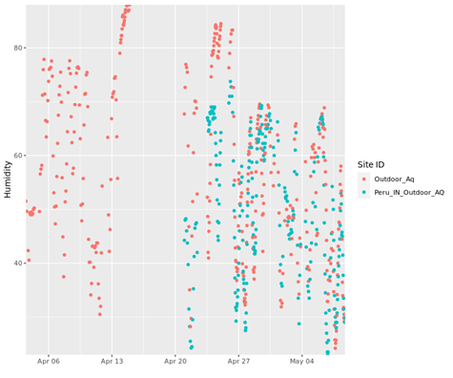

The graph here shows the humidity of the two collection sites. The data depicts that the humidity for the two locations overlap, but Florida consistently has higher humidity levels than Indiana. The large expanses of water near the Florida site in combination with the warmer temperatures allows for the area to experience higher humidity levels. Therefore, the data in this graph did not surprise us when we studied it.

**Pressure**

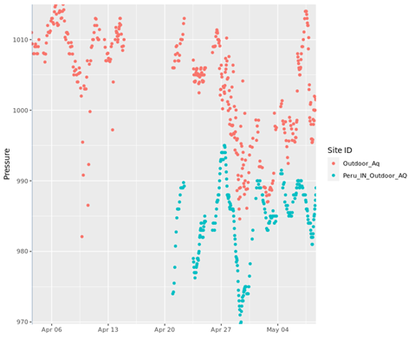

When looking at the graph one can see that the location in Florida experiences higher pressure than the location in Indiana. Additionally, the two data sets seem to relate to one another in the sense that they both rise and fall at the same time. Kiera and I thought that it was interesting how although the sets are different, they are also similar in a sense.

**Conclusion**

From the data shown above one can see that the air from the Florida location is in fact different from the air from the Indiana location. Despite the differences, the data seems to correlate at times and reflect similar changes in the atmosphere. Although we originally though that the data sets would be completely unrelated, it is interesting to see how they intertwine.

**References**

Hosen, J. D. (2020, November 25). *Https://purr.purdue.edu/publications/3632/1*. Retrieved May 04, 2021, from https://purr.purdue.edu/publications/3632/about?v=1.

Volatile organic compounds (VOCs) in your home - EH: Minnesota Department of health. (n.d.). Retrieved May 04, 2021, from https://www.health.state.mn.us/communities/environment/air/toxins/voc.htm